Problem Statement

Create a hive table and load the dataset into the table and evaluate the below problem statements

1. Find out the average HP (Hit points) of all the Pokémons

2. Find out the average Defense of all the pokemon

3. Find out the average Sp.Atk of all the pokemons

4. Find out the average sp.Def of all the pokemons

5. Find out the average Speed of all the pokemons You can download the data set from the below link https://drive.google.com/file/d/0ByJLBTmJojjzZTJQM2UzN2J6aUU/view?usp=sharing DATA SET DESCRIPTION Pokemonid_Number: This column represents id of each Pokémon. Name: This column represents the name of the Pokémon.

Type 1: This column represents the property of a Pokémon.

Type 2: This column represents the extended property of the same Pokémon.

A Pokémon may be one or both the types. For instance, Charmander is a Fire type, while Bulbasaur is both a Grass type as well as a Poison type. With the current 18-type system, there are 324 possible ways to assign these types to Pokémon, along with 171 unique combinations. As of Generation VI, 133 different type combinations have been used. Total: This column represents the sum of all character points of a Pokémon (HP, Attack, Defense, Sp. Atk, Sp. Def, and Speed). HP (Hit Points): This column represents Pokémon Hit Points, which is a value that determines how much damage a Pokémon can receive. When a Pokémon’s HP is down to ‘0’, the Pokémon will faint. HP is the most frequently affected stat of them all, as a depleting HP is a key factor in winning a battle. Attack: This column represents the Attack stat. Defense: This column represents the Defense stat. Sp. Atk: This column represents a Pokémon’s Special Attack stat. Sp. Def: This column represents a Pokémon’s Special Defense stat. Speed: This column represents the speed stat of a Pokémon.

**First we will create table Pokémon using create command**

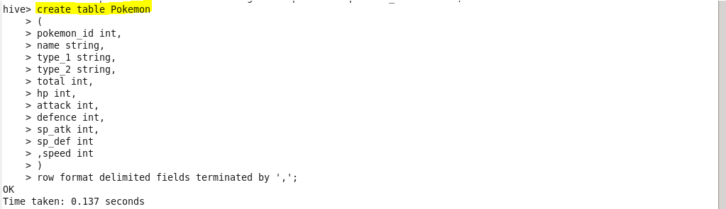

**Load pokemon.txt dataset to Pokémon table**

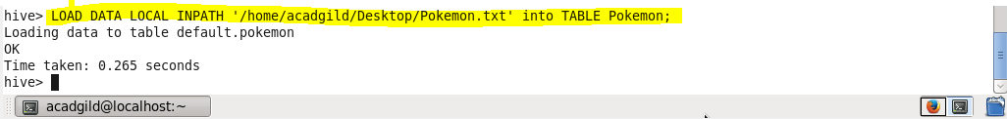

**Q.1. Find out the average HP (Hit points) of all the Pokémon’s**

Using select statement we will display the result

For finding out the average we will use avg function

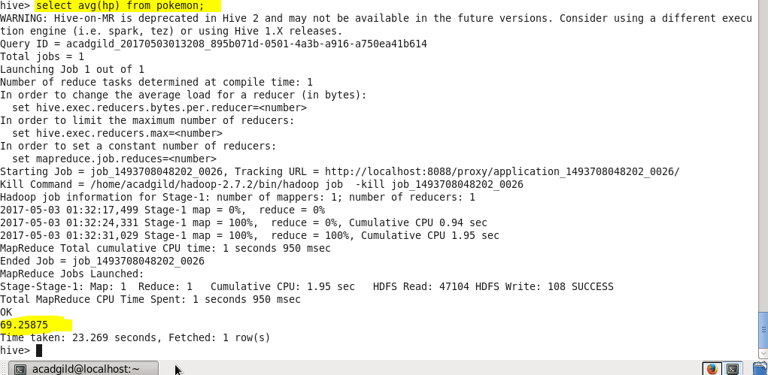

**Q.2. Find out the average Defense of all the Pokémon**

Using select statement we will display the result

For finding out the average we will use avg function

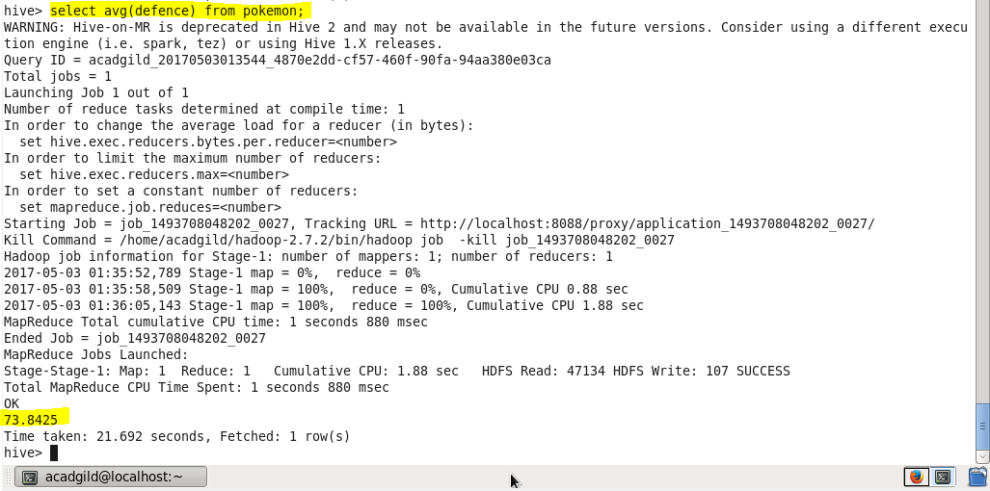

**Q.3. Find out the average Sp.Atk of all the Pokémon’s**

Using select statement we will display the result

For finding out the average we will use avg function

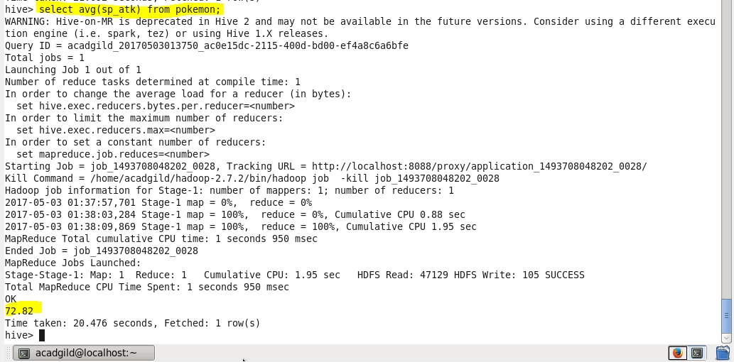

**Q.4. Find out the average sp.Def of all the Pokémon’s**

Using select statement we will display the result

For finding out the average we will use avg function

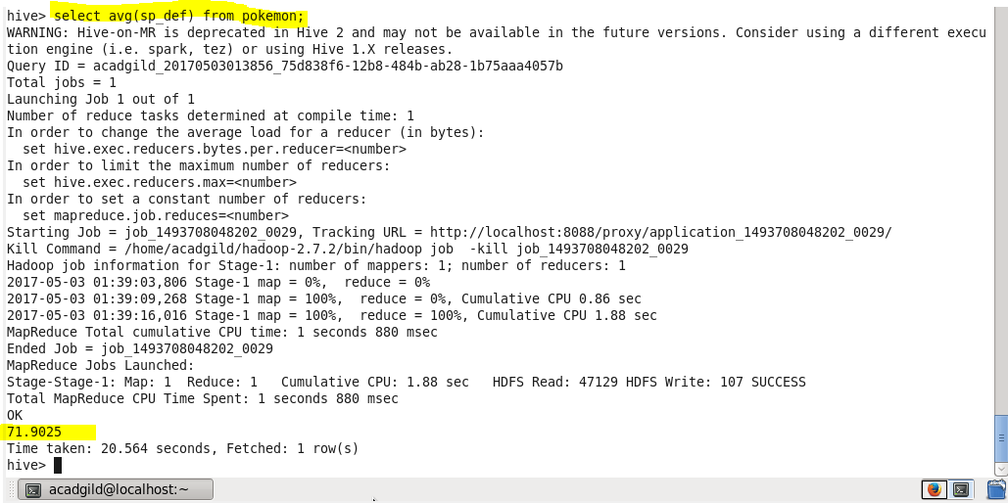

**Q.5. Find out the average Speed of all the Pokémon’s**

Using select statement we will display the result

For finding out the average we will use avg function

